Data Model
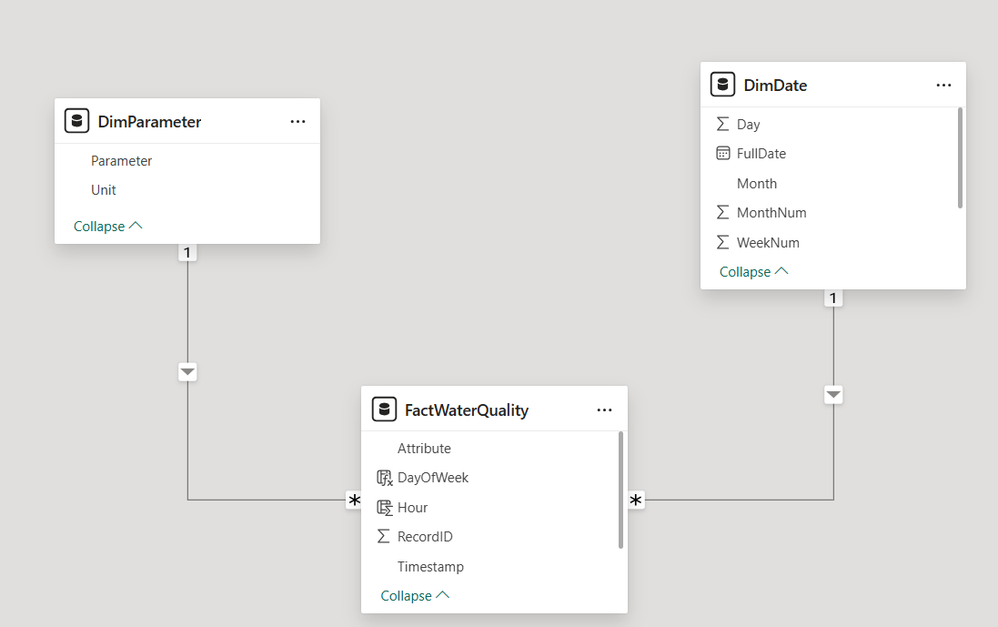

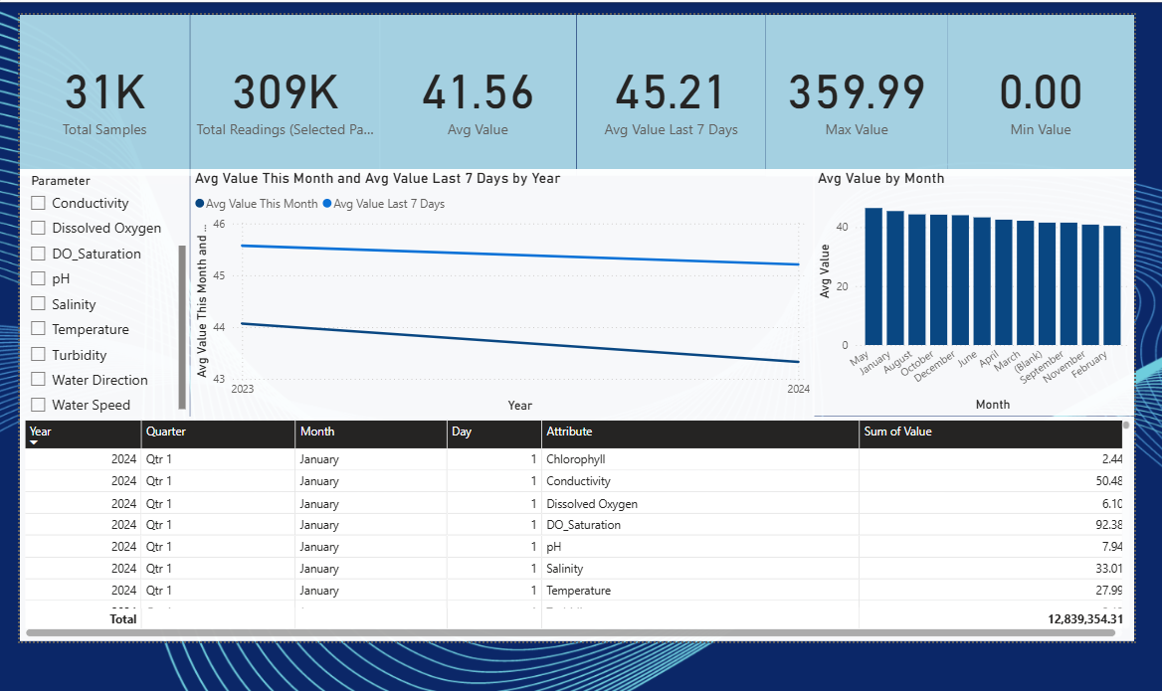
This dashboard is built to monitor water quality trends by parameter over time.
It shows:
- Total number of samples
- Total readings for selected parameter
- Statistical KPIs (Avg, Max, Min)
- Short-term trend metrics (Last 7 days, This month)
- Parameter-based filtering
- Trend line visual
- Monthly comparison
- Detailed drill-down table
It's a mix of KPIs, time series analytics, and detailed data exploration.
SECTION 1 — TOP KPI CARDS (Top Row)
These cards give you quick at-a-glance insights.
1. Total Samples — 31K
This counts unique RecordIDs.
Each RecordID = one water sampling event.
This number does not change when you use the slicer, because it shows total unique samples overall.

2. Total Readings (Selected Parameter) — 309K
This does change when you select a parameter (Temperature, pH, etc.) from the slicer.
It tells you:
How many measurement rows exist for the selected parameter?
The number is higher than Total Samples because each sample contains multiple parameter readings.

3. Avg Value — 41.56
This is the average of Value for the selected parameter.
If you select:
- Temperature → this becomes average temperature
- pH → this becomes average pH
- Turbidity → this becomes average turbidity
This is your main number to monitor parameter performance.

4. Avg Value Last 7 Days — 45.21
This shows the short-term trend.
Formula:
Average of the selected parameter over the most recent 7 days.
Useful for:
- Detecting recent spikes or drops
- Comparing with long-term trend

5. Max Value — 359.99
Highest recorded value for the selected parameter.

6. Min Value — 0.00
Lowest recorded value.
This can help flag anomalies (like 0 values that may be sensor errors).

SECTION 2 — Parameter Filter (Left Sidebar)
This slicer lets you choose which water-quality parameter to analyze:
- Conductivity
- Dissolved Oxygen
- DO Saturation
- pH
- Salinity
- Temperature
- Turbidity
- Water Direction
- Water Speed

SECTION 3 — Trend Line Chart (Center Area)
Title:
“Avg Value This Month and Avg Value Last 7 Days by Year”
This chart shows TWO trend lines:
Avg Value This Month
The average value of the selected parameter for the current month (MTD).
Avg Value Last 7 Days
Rolling 7-day average of the parameter.

What this chart tells you:
- Is the monthly average increasing or decreasing?
- How does the last 7 days compare with the month?
- Are we seeing short-term improvement or decline?
For example:
If Avg Value 7 Days is BELOW Avg This Month → recent drop
If Avg Value 7 Days is ABOVE → upward trend

SECTION 4 — Avg Value by Month (Bar Chart)
This is a seasonality chart.
X-axis: Month
Y-axis: Avg Value
This chart answers:
- Which month has the highest average values?
- Are values declining month by month?
- Are there seasonal patterns?
For example:
Chlorophyll might be high in summer months.
Temperature rises in May–August.
This chart reveals those patterns.

SECTION 5 — Detailed Table (Bottom Section)
This is a drill-down table showing:
Columns:
- Year
- Quarter
- Month
- Day
- Attribute (Parameter)
- Sum of Value
What it shows:
- Detailed daily readings
- Exact measurements
- Breakdowns by year/quarter/month
- For the selected parameter

Example:
If your slicer selects Temperature, the table will show:
Year | Quarter | Month | Day | Attribute | Sum of Value
2024 | Q1 | January | 1 | Temperature | 27.99
It allows deep exploration of raw data.

SECTION 6 — Background / Formatting
Using a blue/aqua theme — very appropriate for water-quality analytics.
The background gradient and borders give a professional, environmental monitoring dashboard feel.

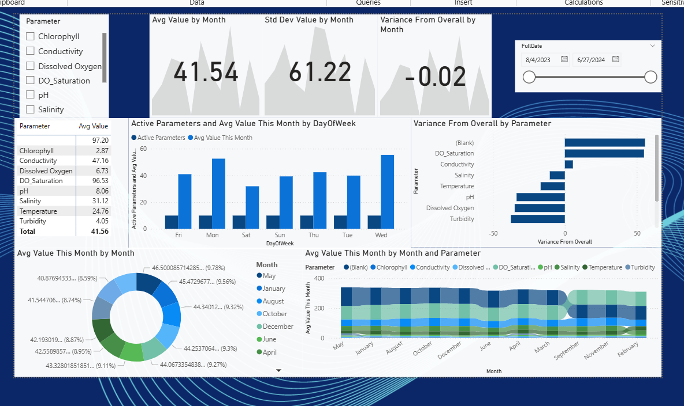
1. LEFT SIDEBAR — Parameter Filter
This slicer lets you select which parameter(s) you want to analyze:
- Chlorophyll
- Conductivity
- Dissolved Oxygen
- DO Saturation
- pH
- Salinity
- Temperature
- Turbidity
What it does:
✔ Updates EVERY visual on the page
✔ Filters the month, day, and variance charts
✔ Updates KPI summary table

2. TOP KPI PANEL (Avg Value / Std Dev / Variance)
This top section shows statistical KPIs for the selected parameter(s).
Avg Value by Month – 41.54
This is the average reading for the selected month or date range.
Std Dev Value by Month – 61.22
Shows the variation / inconsistency of values.
High standard deviation = unstable / inconsistent water readings
Low standard deviation = stable parameter
This is extremely helpful for identifying:
- environmental fluctuations
- sensor instability
- high-variability months
Variance From Overall – -0.02
This measure shows:
How this month's average compares to the overall average across ALL data.
Meaning:
- Negative = below long-term average
- Positive = above long-term average
This is a powerful trend signal.

3. DATE RANGE FILTER
This is a date slicer controlling all visuals.
You can choose:
- specific months
- specific ranges
- year-over-year slices
- seasonal analysis windows
It synchronizes the rest of the page.

4. PARAMETER SUMMARY TABLE
This shows:
Parameter | Avg Value
This is extremely useful when selecting multiple parameters.
It gives you a statistical quick snapshot.
The “Total” row shows the combined average across selected parameters.

5. Active Parameters & Avg Value by Day of Week (Bar Chart)
This visual shows:
X-axis: Day of Week (Mon, Tue, Wed, etc.)
Blue bars: Active Parameters
Number of parameters recorded on that day.
Orange bars (or second series): Average Value This Month
Shows how parameter values behave across the week.
Insights:
- Which days have higher readings?
- Which days are busiest for data collection?
- Weekly patterns and cycles
- Whether weekends differ from weekdays
This is a great operational + scientific combo.

6. Variance From Overall by Parameter (Horizontal Bar Chart)
One of the strongest visuals in the dashboard.
Each parameter gets a bar showing how far it deviates from overall mean.
Interpretation:
- Positive = parameter is trending HIGHER than long-term average
- Negative = trending LOWER
- Larger bar = greater deviation
This instantly identifies:
🔹 Parameters that are rising
🔹 Parameters that are declining
🔹 Abnormal spikes
🔹 Seasonal shifts
It’s a very scientific and analytical indicator.

7. Avg Value This Month by Month (Donut / Ring Chart)
Shows monthly composition of the current month's average.
Helps answer:
- Which months contribute most to the current average?
- Are some months consistently higher or lower?
- Do certain months dominate the measurement history?
Most useful for:
- Seasonal effects
- Climate cycles
- Annual monitoring

8. Avg Value This Month by Month AND Parameter (Heatmap / Matrix Chart)
This is one of the most advanced visuals on the page.
X-axis: Month
Y-axis: Parameter
Color intensity: Avg Value
This heatmap shows:
✔ Seasonal patterns
✔ Which parameters spike in specific months
✔ Multi-parameter comparisons across time
For example:
- Chlorophyll may spike in summer
- Temperature rises in June–August
- Turbidity may spike during rainfall months
This is a scientific pattern recognition chart.
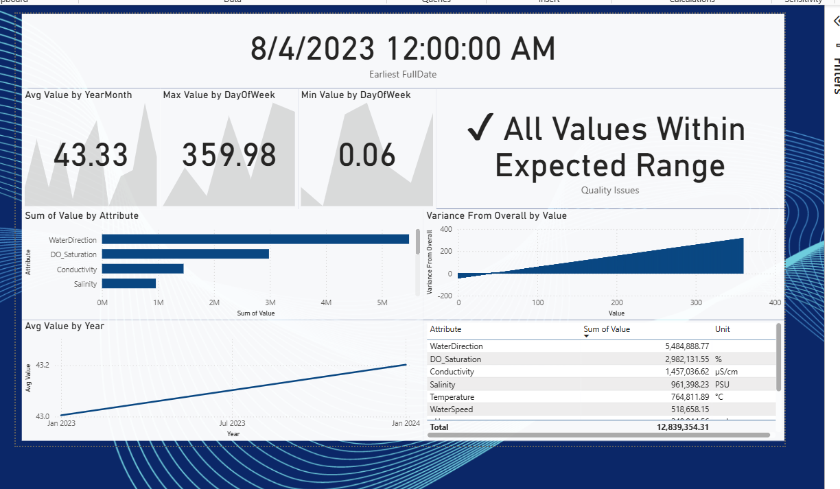
1. Big Header — Selected Date (8/4/2023 12:00 AM)
At the top, you see:
8/4/2023 12:00:00 AM
Earliest FullDate
This tells you:
- Which specific date/time you drilled into
- All visuals below reflect ONLY that day’s data
- It locks the context to that sample day
This works because of the Drillthrough filter on:
- FullDate
- RecordID

2. KPI Cards — Statistical Summary for That Date
You have three KPI cards showing:
✔ Avg Value by YearMonth — 43.33
The average reading across all parameters on that date.
✔ Max Value by DayOfWeek — 359.98
The highest sensor reading recorded on that specific date.
This is typically temperature / water direction / speed spikes.
✔ Min Value by DayOfWeek — 0.06
The lowest sensor reading recorded.
This helps detect:
- Faulty sensors
- Zero readings
- Negative anomalies (if any)

3. Quality Issues Card — Status Check
This card shows:
✔ All Values Within Expected Range
This card comes from a DAX measure like:
Quality Issues =
IF ( MIN(FactWaterQuality[Value]) < 0,
"⚠️ Possible Quality Issues",
"✔ All Values Within Expected Range"
)
This is extremely useful for:
- Environmental agencies
- Data auditors
- Maintenance engineers

4. Sum of Value by Attribute (Horizontal Bar Chart)
This chart shows how each parameter contributes to the total value for that date.
Example:
- WaterDirection → 5.48M
- DO_Saturation → 2.98M
- Conductivity → 1.45M
- Salinity → 0.96M
What insights it gives:
✔ Which parameters dominate on this day
✔ Heavy-impact parameters
✔ Outlier-high parameters
✔ Possible sensor biases
Values are very large because your units (e.g., µS/cm, °C) differ.

5. Variance From Overall by Value (Bar Chart)
This chart plots:
Variance From Overall = Today’s value – Overall long-term mean
Interpretation:
- Positive variance → Higher than normal
- Negative variance → Lower than normal
- Zero → Normal for long-term range
This helps detect:
✔ Environmental anomalies
✔ Spikes/drops
✔ Seasonal deviations
✔ Sensor drifts
Example from your image:
- Many values are above 0 (positive variance)
- So this day is higher than long-term average

6. Avg Value by Year (Trend Line)
This is a trend chart that shows:
✔ How the selected parameter or all parameters behave across years
✔ Long-term change
✔ Year-to-year variation
For example:
- Jan 2023: ~43.0
- Jan 2024: ~43.2
This shows a slight upward trend.

7. Detailed Table — Attribute, Sum of Value, Unit
This is a breakdown table listing each parameter:
Attribute | Sum of Value | Unit
WaterDirection | 5,484,888.77 | °
DO_Saturation | 2,982,131.55 | %
Conductivity | 1,457,036.62 | µS/cm
Salinity | 961,398.23 | PSU
Temperature | 764,811.89 | °C
WaterSpeed | 518,658.15 | m/s
Plus a total at the bottom.
What this table tells you:
✔ The exact measurement totals
✔ Unit of measurement
✔ Parameter-by-parameter detail
✔ How each measurement compares
✔ Helps with scientific review and QA

